Project proposal on

**Interactive Tutorial Platform**

Module: Computing Project

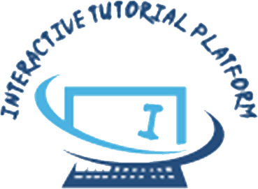

**Submitted by:** **Submitted to:**

Amulya Shrestha Sudeep Bajiyama Sir

NCC ID: 00174311 Module Leader

Batch 22A

Softwarica College of IT and E-Commerce

April 9, 2019